**Adya Ayurveda**

Online Database Manual

v 2.0

Table of Contents

Preface 3

User Management System 4

User Data Fields 4

Users 5

Managing Users 5

Content Management System 7

Pages 7

Managing Content 7

Knowledge Base 8

Diseases 8

Modalities 8

Articles 9

Product Management System 10

Managing Products 10

Ordering Management System 11

Managing Orders 11

Invoice Management System 12

# Preface

To access the management system you will need to login.

Click or go to the following link:

<http://adya-ayurveda.com/login>

Use the following credentials:

**Email** - sarita_nahar@hotmail.com

**Password** – El3phant­­

For the SMS reminders to work, I need you to sign up to the following service:

<http://www.textlocal.com/signup>

You get 10 free credits, but you will need to top up your account as and when you need. Initially I would recommend a small top up just to start with. Once you have done this, you need to send your login Details to me so that I can connect the service to your website. After that it should Work seamlessly.

# User Management System

## User Data Fields

The user data fields section is accessible under the Users tab in the main navigation. After clicking the link you will be presented with a list of data fields that already exist in the system (***index view***).

To add a user data field, click the new data field button in the top right corner of the index view.

You will now be presented with a form that looks like the below image:

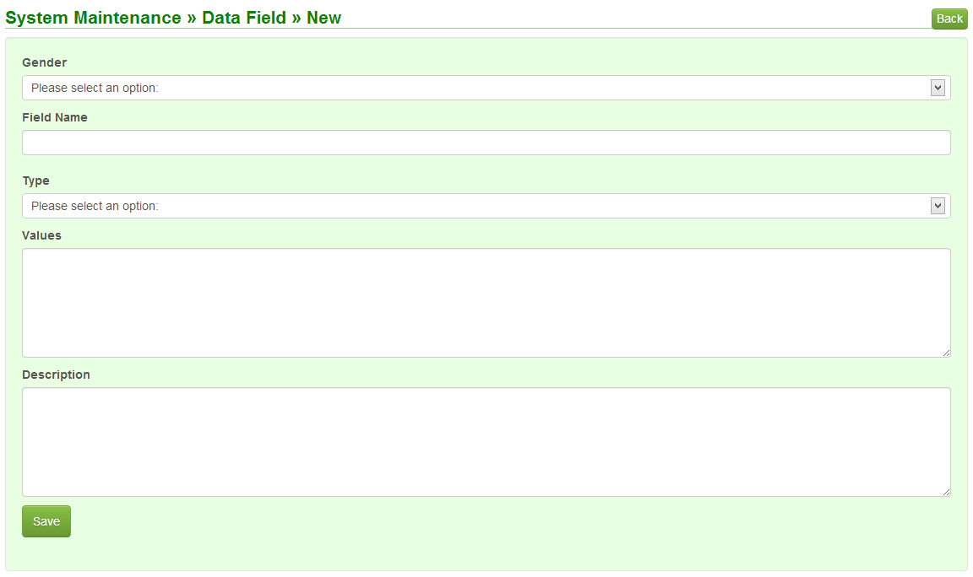

* The gender field will allow you to set whether the field should be displayed for either males, females or both genders.
* The field name as you want it to appear on the patient’s profile.
* The type field allows you to select between different input method:
  + List – dropdown
  + True or False – checkbox
  + Text – single line input
  + Long Text – multi-line resizable input
* The values field is only required if the above type option is set to list, it will accept a comma separated string of options.
* The description field is for future reference and to describe each field as you create them.

To edit a user data field, click the actions button on the index view and then edit.

To delete a user data field, click the actions button on the index view and then delete.

## Users

To access the users, you will need to click on the users tab in the main navigation and then click on the all users link. This will load a tabbed (***index view***) of all users divided by group. From here you can view or delete each user. Users cannot be permanently deleted but instead they are disabled.

### Managing Users

Click on the New User button in the top right corner of the users index view. This will load the following form:

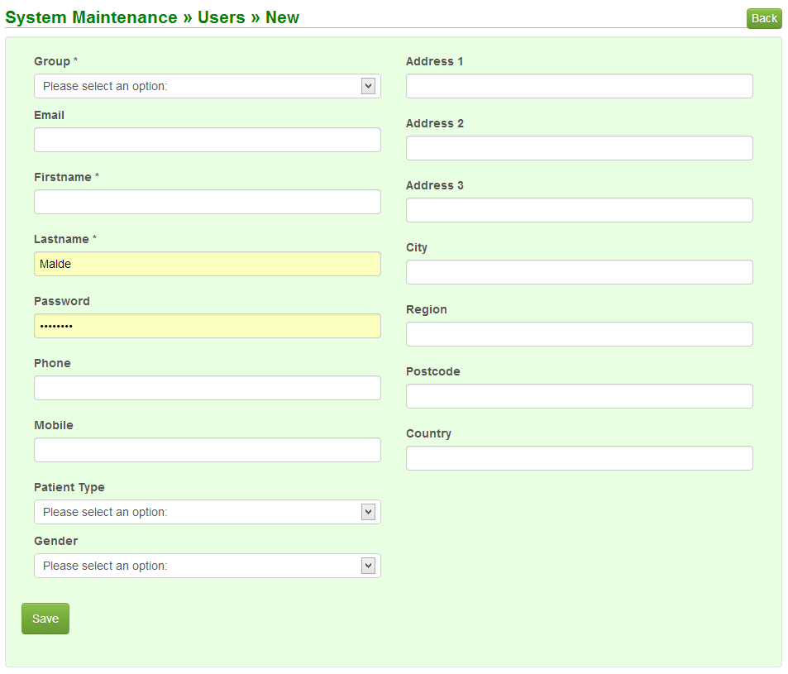

* The group field specifies which group the user will belong to. Most of the time this will be the patients group.
* All other fields are self-explanatory.
* The user data fields will not show up here as these are determined by the patient’s gender.
* After you save the user you will be redirected to the view / edit page. The page will look like the below image:

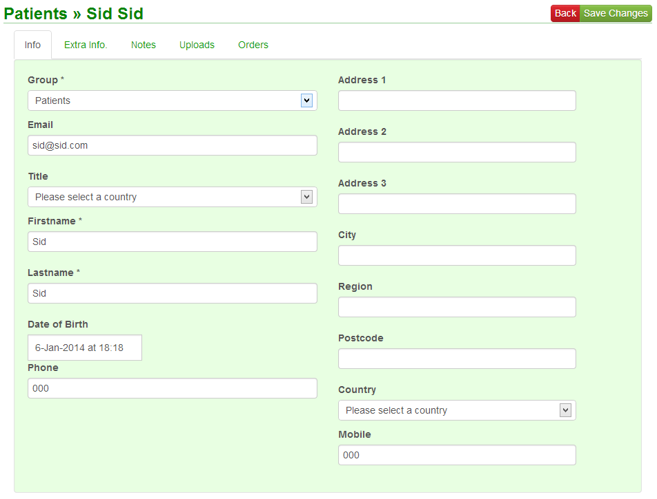In the above image you will notice there are a few tabs:

* Info – This is similar to the add page however you will not be able to adjust the gender of age group of the patient.
* Extra Info – This is where the user data fields will be shown and will be editable.
* Notes – In the notes tab you will be able to add, edit and delete notes. The user that created the note will be recorded as well as the date / time.
* Uploads – here you will be able to upload different files that are associated with the patient.
  + Allowed formats – (***doc, docx, xls, xlsx, pdf, jpg, jpeg, gif, png, tiff***)
* Orders – The orders tab allows you to see the orders linked to that patient. It will show the order ref, and the total amount for the order. If you click on the bar, it will expand and give a breakdown of each item in the order, there is also an actions button to edit the order item or delete it.

# Content Management System

## Pages

To manage the website content you will need to navigate to the pages section. This can be found under the CMS main navigation tab, click the pages link. This will load the pages index view.

### Managing Content

Click on the link in the top right corner of the index view, New Page, this will load the following form:

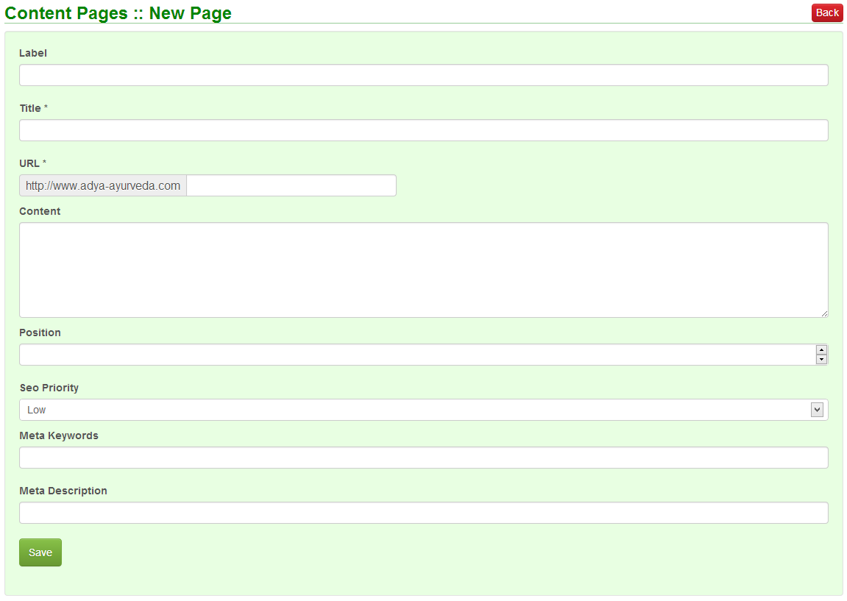

* Label – This field is used as the text for the tab on the front-end navigation menu bar.
* Title – This is the page’s title and is very important for SEO, it should be concise and relevant to the page’s content.
* URL – This field allows you to determine the url of the pags, hyphenated urls are the best for SEO as they give meaning to a url. E.g. [www.adya-ayurveda.com/about-us](http://www.adya-ayurveda.com/about-us)
* Content – This is where the page’s content will be written and published. The input field accepts HTML and is resizable for large sets of content.
* Position – The order in which the page should appear in the navigation menu bar.
* SEO Priority – This field allows you to determine how important a page is to a search engine. Do not give all pages a high priority, only the essential ones.
* Meta keywords & Meta description – are both hidden fields that do not display on the website to users but do display to search engines. They can be used to help a search engine better understand what the page content is related to.

To edit a page navigate to the pages index view and click the actions button of any page and click the edit link.

To delete a page navigate to the pages index view and click the actions button of any page and click the delete link.

## Knowledge Base

### Diseases

To be able to manage the diseases you will need to click on the knowledge base link in the main navigation menu and click the diseases link. This will load the index view for diseases. To create a new disease, click on the link in the top right corner labelled New Disease, this will load the following form:

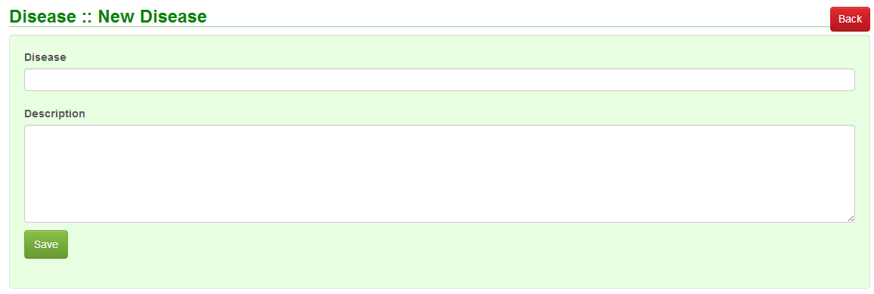

The above fields are self-explanatory.

### Modalities

To be able to manage the modalities you will need to click on the knowledge base link in the main navigation menu and click the modalities link. This will load the index view for modalities. To create a new modality, click on the link in the top right corner labelled New Modality, this will load the following form:

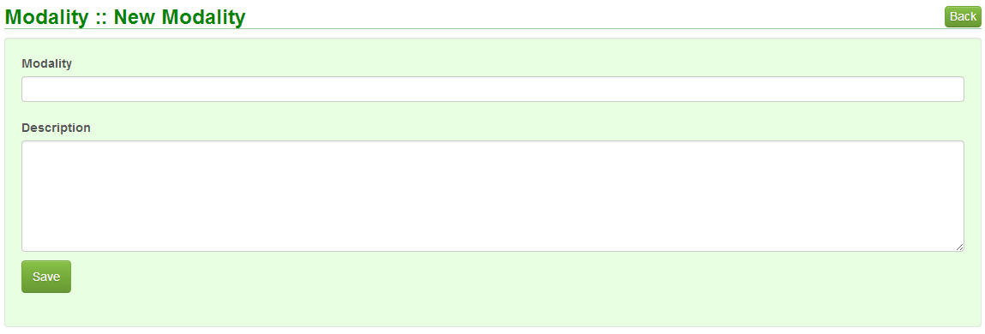

The above fields are self-explanatory.

### Articles

To view the articles you have 2 options, you can either click on the articles link under the Knowledge Base link in the main navigation bar or via the disease.

* First we will go directly to the articles link. This method will show all articles for all disease split by modality in a tabbed view. There are filters available to search the table for the correct article.
* For the second method we will go to the disease index view and click the actions button next to a disease and click the view link. Here you will get a tabbed view for each modality and the details associated with that disease and modality.
* To manage an article you will need to navigate to the articles link and click the New KB Article button. This will load the following form:

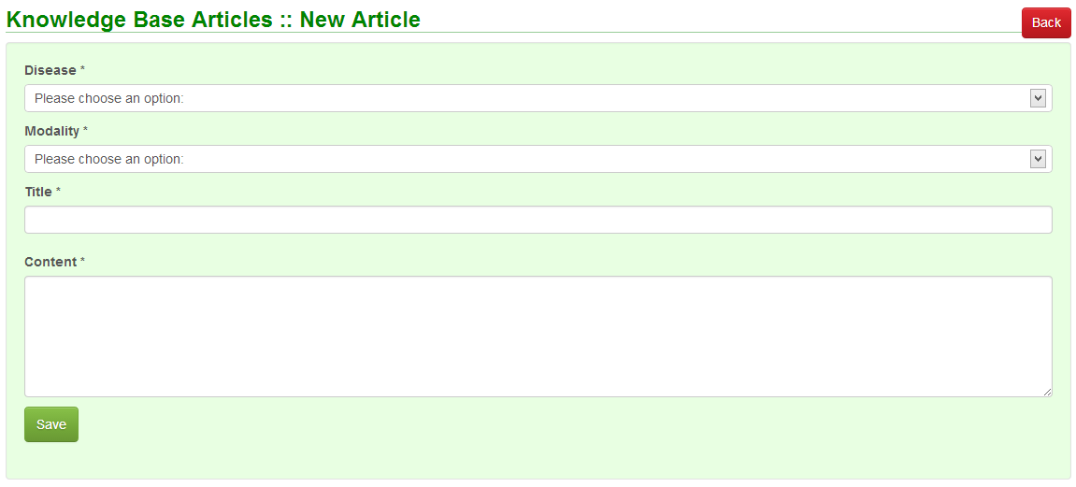

* The disease field lists all the diseases that have been entered.
* The modalities field lists all the modalities that have been entered.
* The other 2 fields are self-explanatory.

You can edit or delete an article by clicking on the actions button in the articles index view.

# Product Management System

The products management system can be accessed by clicking products in the main navigation bar, this is the index view.

## Managing Products

Click on the New Product button in the top right corner, the following form will be loaded:

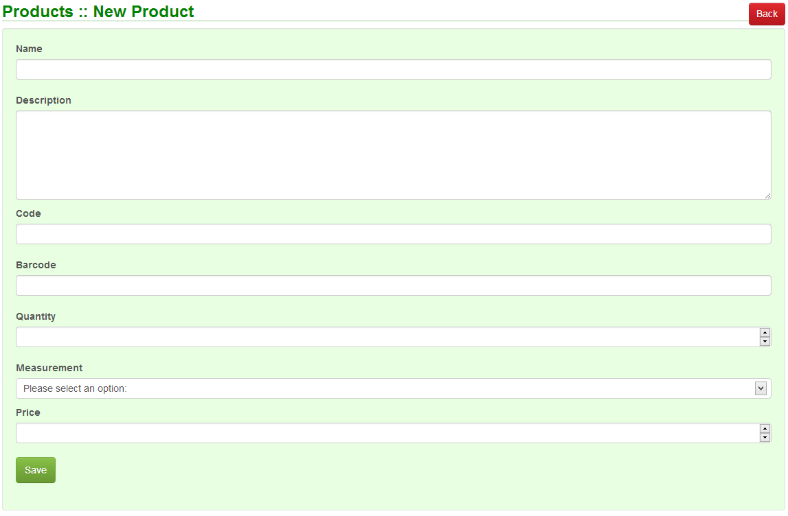

Fill out the above form and click the save button to add a product.

To manage a product you can click on the actions button on any product from the index view and either edit or delete it.

# Ordering Management System

The orders management system can be accessed by clicking orders in the main navigation bar, this is the index view.

## Managing Orders

Click on the New Order button in the top right corner, the following form will be loaded:

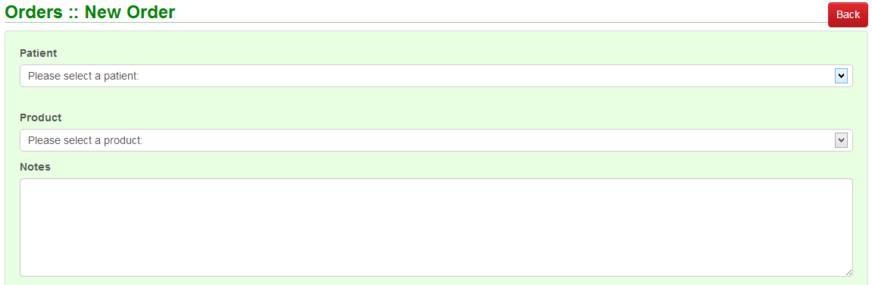

The above form is a small section of the actual form; the real form has up-to 6 product sections to allow you to add multiple products to an order. There are 3 simple fields to fill in, the patient the order is for, the product and any notes that you would like to enter against the product. After clicking the save button the order will be created and the order will also be associated with the correct user.

# Invoice Management System

Click on the invoices tab in the navigation bar. From here you will be able to invoice any orders that haven’t already been invoiced and view the PDF invoice of ones that have been.

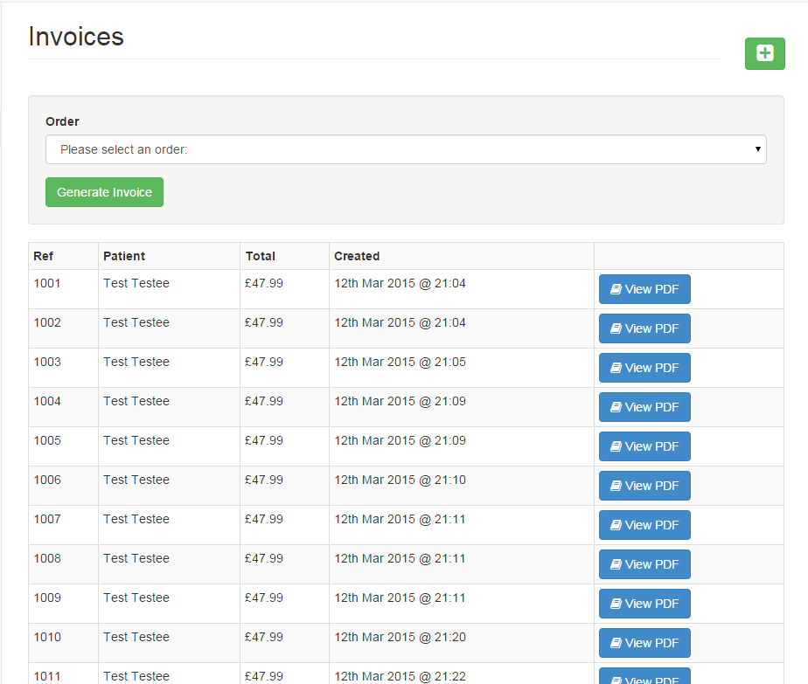

2

1. From here you can access a dropdown which will show you all orders that have not been invoiced yet. Select an invoice and then press generate invoice.
2. From here you can view the PDF of the invoice.

Appointment Management System

Click on the Appointments tab in the navigation bar. From here you will be able to add, edit and view calendar events.

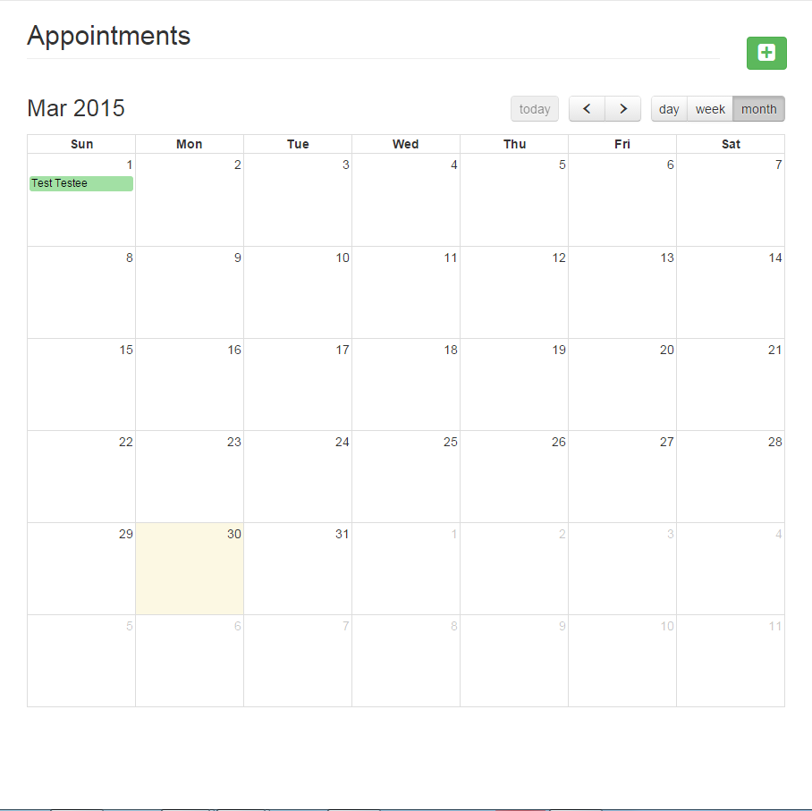

1. Clicking this button will open the below pop-up. It will allow you to add a new appointment. You can choose from a list of employees and the date fields will bring up a mini-calendar.

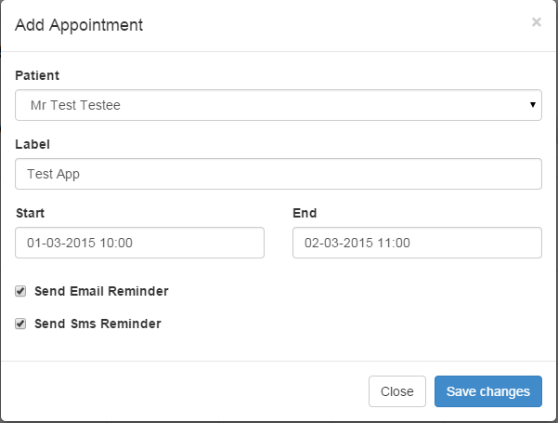

1. If you click on an appointment that already exists in the calendar, you will be able to edit the label and dates of the appointment.